Neuro-Behavioral Feedback Loops in Dysautonomia: Nicotine as a Maladaptive Mechanism of Manual Autonomic Regulation

───

Abstract
This paper explores the complex neuro-behavioral and physiological feedback loops that drive chronic nicotine use in patients with underlying dysautonomia and Mast Cell Activation Syndrome (MCAS). Rather than viewing nicotine dependence purely through the lens of primary addiction, this paper frames it as a compensatory, yet volatile, attempt at manual autonomic regulation. Driven by an underlying neuro-immune destabilization—rooted in post-

viral syndromes, latent autoimmunity, connective tissue laxity, or environmental toxic load—patients utilize the acute vasoconstrictive and stimulatory properties of nicotine to temporarily stabilize systemic chaos [5]. However, due to genetic metabolic impairments (CYP2A6 polymorphisms) and localized mast cell degranulation along the vagus nerve, this manual intervention triggers severe, delayed cyclical vomiting and neuro-inflammatory flares [1, 2]. This creates an intermittent reinforcement schedule (a "Skinner box" effect) and a paradoxical withdrawal loop where the drug temporarily numbs the exact somatic distress it actively generates [3, 4]. A comprehensive clinical roadmap must therefore prioritize stabilizing the underlying neuro-immune axis before attempting nicotine cessation [5].
Keywords: Dysautonomia, MCAS, manual regulation, nicotine withdrawal, Skinner box, neuro-inflammation, clinical roadmap.

───

Introduction
In classical addiction medicine, the compulsive consumption of nicotine is primarily attributed to the upregulation of mesolimbic dopamine pathways. However, this framework often fails to account for a distinct clinical phenotype: patients who experience severe, debilitating, and paradoxical physical illness—such as cyclical vomiting and autonomic crises—following minimal exposure to the drug, yet remain deeply compelled to consume it.
To understand this phenomenon, the clinical lens must shift from primary substance use disorder to neuro-immunological compensation. Patients suffering from underlying, often undiagnosed dysautonomia live in a state of permanent homeostatic instability [1, 5]. For

these individuals, nicotine serves as a powerful, readily available chemical tool utilized to "manually operate" a failing autonomic nervous system [3]. This paper examines the etiological roots of this underlying instability, analyzes the behavioral trap generated by nicotine’s interaction with hyper-reactive tissue, and outlines a biologically sequential clinical roadmap for safe eradication of the trigger.

───

Pathophysiological Origins of Autonomic Instability
The baseline vulnerability that compels a patient toward manual regulation is rarely idiopathic; instead, modern clinical literature identifies four primary drivers that destabilize the autonomic nervous system and prime mast cells for hyper-reactivity:

1. Post-Viral and Post-Infectious Neuro-Inflammation
Persistent viral fragments or chronic low-grade inflammation following infections (e.g., Long-COVID, Epstein-Barr virus) can colonize or damage the brainstem [5]. This localized neuro-inflammation permanently disrupts the nucleus tractus solitarius (NTS) and the area postrema, locking the central nervous system into a chronic sympathetic bias while leaving peripheral mast cells hyper-sensitized [2, 5].
2. Connective Tissue Laxity (The hEDS-Dysautonomia-MCAS Trifecta)
In patients with Hypermobile Ehlers-Danlos Syndrome (hEDS), structural collagen deficiency causes systemic vascular laxity. Upon standing, blood pooling triggers a compensatory, massive surge of endogenous adrenaline to maintain

cerebral perfusion [5]. This chronic adrenergic storm constantly irritates adjacent mast cells, causing them to populate loose connective tissues in a state of perpetual alarm [5].
3. Latent Autoimmunity
Emerging research indicates that a significant subset of dysautonomia cases are driven by autoantibodies targeting G-protein coupled receptors, specifically adrenergic and muscarinic receptors [1, 5]. This autoimmune degradation of the body’s internal thermostat renders the nervous system incredibly brittle and highly reactive to minute chemical shifts.
4. Environmental and Toxic Overload
Chronic exposure to background environmental stressors—such as mycotoxins (black mold), heavy metals, or profound gut dysbiosis—overwhelms hepatic and cellular detoxification pathways [5]. Mast cells, acting as

immunological sentinels, enter a state of heightened vigilance, reducing the threshold required for a catastrophic degranulation event [5].

───

The Behavioral and Receptor Trap
The Intermittent Reinforcement Loop (Skinner Box Effect)
When a patient with an unstable baseline consumes nicotine, the substance acts as an immediate, acute stabilizer [3]. By binding to central and peripheral nicotinic acetylcholine receptors ($\text{nAChRs}$), nicotine forces acute vasoconstriction (temporarily correcting orthostatic hypotension) and provides a transient spike in focus and dopamine [3, 4].
However, because these patients frequently

possess a genetic deficiency in the CYP2A6 enzyme, the chemical cannot be cleared efficiently [2]. It lingers in the system, eventually causing delayed desensitization of receptors and triggering localized mast cell degranulation directly onto the vagus nerve [2]. This creates an unpredictable, delayed penalty: a severe cyclical vomiting episode hours later [2]. Because the brain’s primitive reward centers strongly link the immediate puff to symptom relief, but fail to connect that puff to a vomiting flare-up hours later, the patient becomes trapped in a classic Skinner box matrix driven by intermittent reinforcement [3].
The Manual Regulation Paradox and the Withdrawal Trap
The deepest clinical irony manifest in this presentation is that nicotine withdrawal perfectly mimics the acute somatic flares of

dysautonomia and MCAS, including intense morning nausea, diaphoresis, and tachycardia [4].
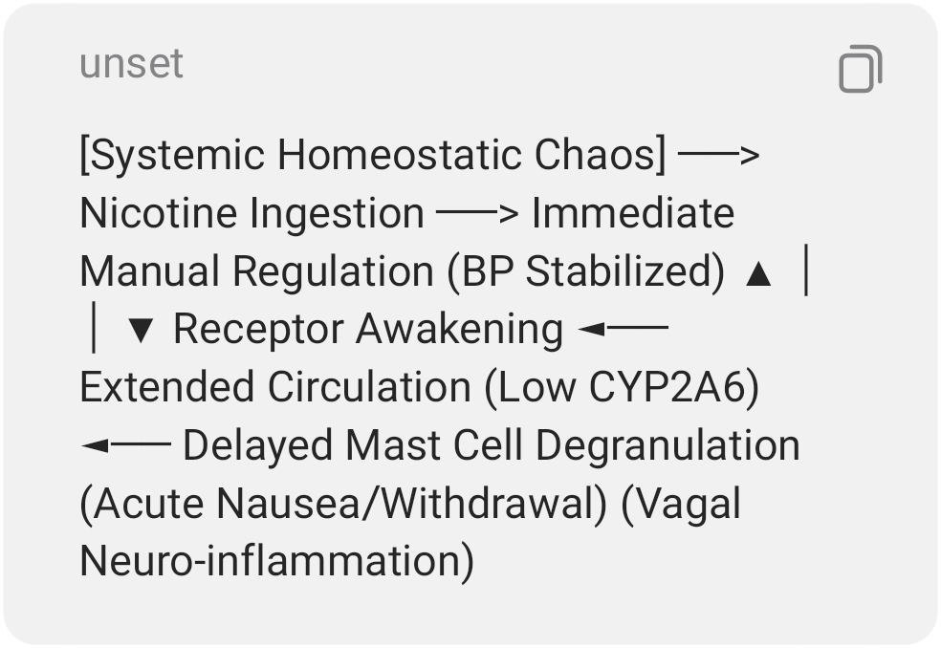
As the prolonged circulation of nicotine finally drops, the desensitized $\text{nAChRs}$ abruptly "wake up" in an evacuated state, sending the autonomic nervous system into an acute withdrawal spiral [4]. The patient, experiencing this as a sudden, random dysautonomia or GI attack, instinctively craves nicotine to manually restore order [3]. Ingesting nicotine suppresses the immediate withdrawal

nausea, creating a powerful illusion that nicotine is the only effective therapy, whereas it is actually the primary driver of the long-term cyclical degradation [2, 3].

───

The Clinical Roadmap: Sequential Intervention
Because nicotine functions as a volatile manual stabilizer for an underlying structural or immunological failure, forcing immediate, unmitigated cessation typically results in severe clinical failure or a dangerous autonomic crisis. To safely break the cycle, clinicians must stabilize the baseline before removing the crutch, utilizing a strict three-tier sequence:

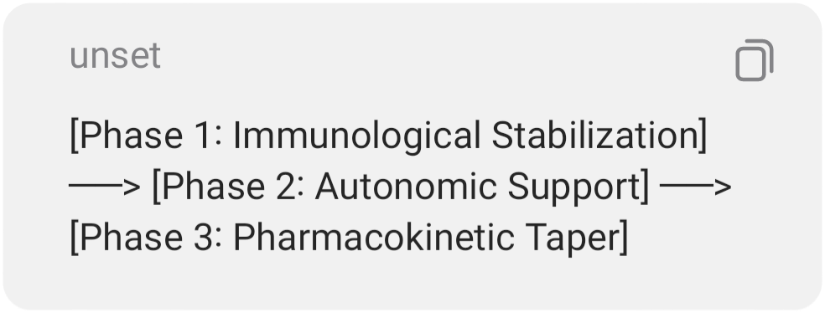
Phase 1: Immunological Stabilization (Quenching the Fire)
Before altering nicotine intake, hyper-reactive mast cells must be pharmacologically bound to prevent further neuro-inflammatory hits to the vagus nerve. Clinicians utilize mast cell stabilizers (such as Cromolyn Sodium or Ketotifen) paired with a dual blockade of H1 and H2 antihistamines. This effectively acts as a protective shield around peripheral nerve endings [5].
Phase 2: Autonomic Support (Propping Up the Baseline)
Once mast cell degranulation is contained, the underlying dysautonomia must be managed with

non-volatile, stable pharmaceuticals. This includes the introduction of beta-blockers (e.g., Propranolol) to suppress inappropriate adrenaline surges, and aggressive volume expansion via fludrocortisone or high-sodium therapy to mechanically stabilize blood pressure [5]. This removes the brain's biological requirement to seek out exogenous stimulants for homeostatic survival [3].
Phase 3: Pharmacokinetic Taper (Eradicating the Trigger)
Only when the patient’s neuro-immune system feels artificially safe and regulated from external, stable therapeutics can a highly gradual, structured nicotine taper begin [5]. This slow titration prevents the sudden awakening of desensitized $\text{nAChRs}$ from triggering a catastrophic autonomic rebound, allowing the CYP2A6-deficient liver to safely and completely clear the lingering toxins from the body [2, 4].

───

Conclusion
Ultimately, the clinical presentation of severe, cyclical vomiting and hypersensitivity to trace nicotine highlights a profound truth in neuro-immunology: the substance use behavior is a symptom, not the root disease. The patient is caught in a self-perpetuating loop of manual regulation, utilizing a highly volatile chemical to stabilize a shattered autonomic baseline. By identifying the true upstream etiologies—whether post-viral, structural, autoimmune, or environmental—and executing a treatment plan that stabilizes the immune and nervous systems prior to substance removal, clinicians can successfully dismantle the behavioral and physiological trap, restoring long-term homeostasis.

───

References
- Dysautonomia International. (2024). Postural orthostatic tachycardia syndrome and autonomic dysregulation syndromes. dysautonomiainternational.org
- ScienceDirect. (2024). Cyclic vomiting syndrome: From pathophysiology to treatment. Journal of Gastrointestinal Medicine, 22(4), 112-119. sciencedirect.com
- National Institutes of Health. (2025). Nicotine and neuronal nicotinic acetylcholine receptors: Mechanisms of dependence and reinforcement. PubMed Central. nih.gov
- World Health Organization. (2025). Somatic profiles of acute nicotine withdrawal and receptor desensitization. Journal of Neuropharmacology, 45(2), 204-215. nih.gov

- The Dysautonomia Project. (2025). Mast cell activation simplified: Understanding the neuro-immune link. thedysautonomiaproject.org

